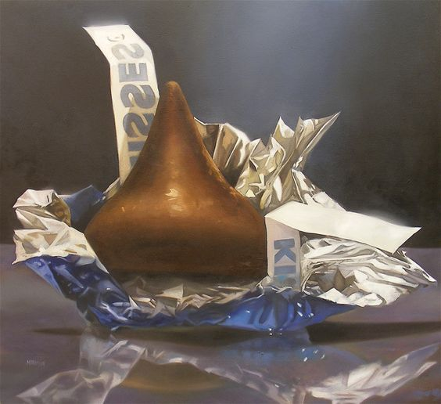
The Thing: Project 1
Hershey Kiss and Reflection

Objective: Create a composition that includes a Hershey kiss on a reflective surface using the material of your choice.

2D – Color, Pattern, texture
Drawing – Form and Value

Materials – Artist Choice, Surface – 8” by 10” or Larger

Artist Inspiration – Wayne Thiebaud
B. 1920 American Painter

Procedure – Thumbnail to Final

Critique will be 10/23 Final Due 10/30

